**Worksheet-2.4**

**Student Name:-** Pushpraj Roy **UID:-** 20BCS9866

**Branch:-** BE- CSE **Section/Group:-** WM_617 “A”

**Subjetct Code:-** 20CSP-317 **Semester:-** 5th

**Subject Name:-** Machine Learning Lab

1. **Aim/Overview of the practical:-**

Implement Decision Tree and compare the performance with Random Forest on any data set.

1. **Task to be done/ Which logistics used:-**

To prepare a model with Decision Trees and Random Forests algorithm.

1. **Steps for experiment/practical/Code:-**

import pandas

from sklearn import tree

from sklearn.tree import DecisionTreeClassifier

import matplotlib.pyplot as plt

df = pandas.read_csv("data.csv")

d = {'UK': 0, 'USA': 1, 'N': 2}

df['Nationality'] = df['Nationality'].map(d)

d = {'YES': 1, 'NO': 0}

df['Go'] = df['Go'].map(d)

features = ['Age', 'Experience', 'Rank', 'Nationality']

x = df[features]

y = df['Go']

print(x)

print(y)

dtree = DecisionTreeClassifier()

dtree = dtree.fit(x,y)

tree.plot_tree(dtree, feature_names=features)

print(dtree.predict([[40,10, 7, 1]]))

1. **Result/Output/Writing Summary:-**

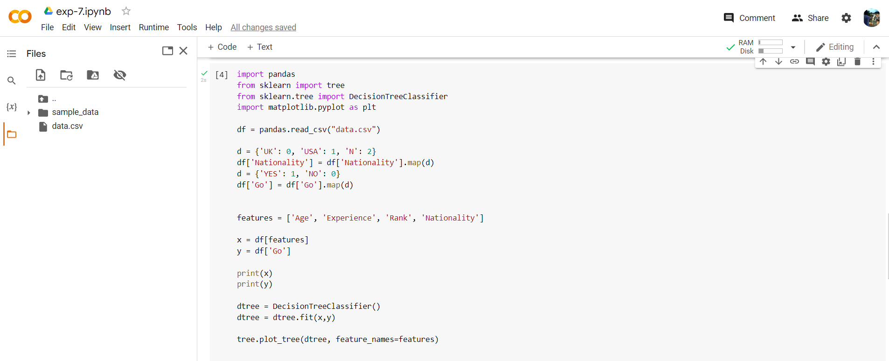

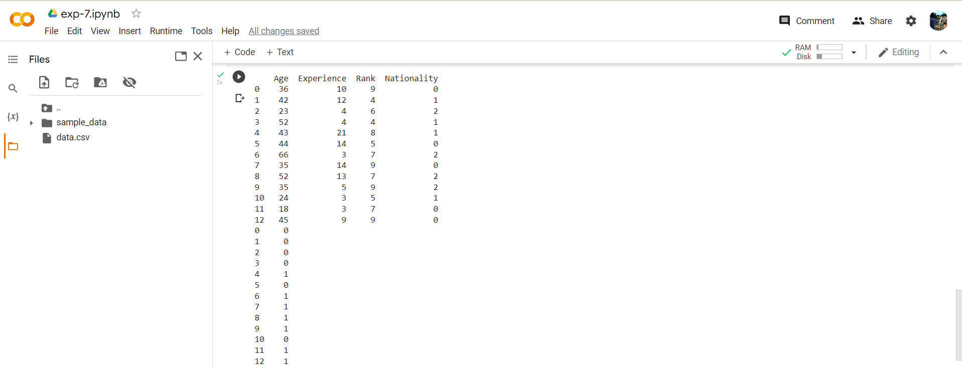

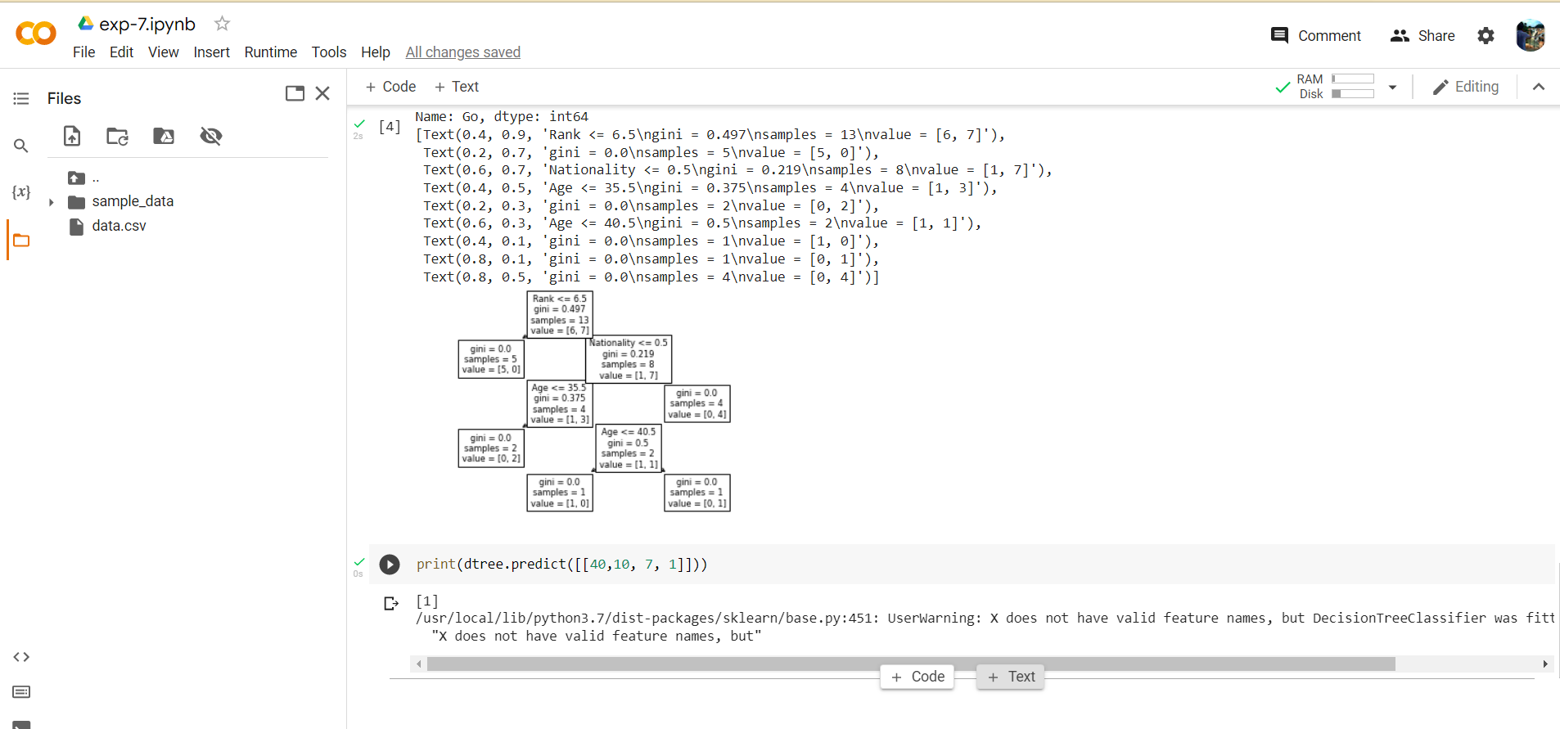

1. **Learning outcomes (What I have learnt):**

* Understood the concept of Decision Tree.
* Learnt how to load the dataset and map it.
* Printing the data according to the feature available in the dataset.
* Plot the Decision Tree and predict it

**Evaluation Grid (To be created as per the SOP and Assessment guidelines by the faculty):**

|  |  |  |  |
| --- | --- | --- | --- |
| Sr. No. | Parameters | Marks Obtained | Maximum Marks |
| 1. |  |  |  |
| 2. |  |  |  |
| 3. |  |  |  |